Shubhadip Maity

COMPUTER APPLICATION STUDENT

# CONTACT ME

 +91 9064065535

* [shubhadipmaity041@gmail.com](mailto:shubhadipmaity041@gmail.com)

174857.pngGitHub-Mark.pnghttps://[www.linkedin.com/in/shubhadip-](http://www.linkedin.com/in/shubhadip-) maity-743a29227/

https://github.com/ShubhadipMaity

Uttar Dauki,Junput Coastal, Contai ,Purba Medinipur- 721450

# PARSONAL INFORMATION

 D.O.B: 20'th October, 2002.

## Nationality: Indian.

 Hobbies: Coding, Watching

## movies,Playing Cricket

 Languages Known: English,

Hindi, Bengali.

# TECHNICAL SKILLS

Languages : JAVA, SQL

Web Designing: HTML, CSS, BOOTSTRAP

Advance Java : Hibernate ,Servlet , JSP, Oracle Database , MySQL Database

# EDUCATION HISTORY

**RCC INSTITUTE OF INFORMATION TECHNOLOGY , MAKAUT**

Master of Computer Applications | 2022- 2024

**PRABHAT KUMAR COLLEGE, CONTAI, VIDYASAGAR**

**UNIVERSITY**

Bachelor of Computer Applications | [88.38%]

2019-2022

|  |  |
| --- | --- |
| **VIVEKANANDA ADARSHA SIKHANIKETAN** | |
| WBCHSE Board (Class XII) | [75.2%] | 2019 |
| MAJILAPUR BIRENDRA VIDYAPITH  WBBSE Board (Class X) | [51.4%] | 2017 |

## 

**PROJECT**

SCHOOL MANAGEMENT SYSTEM USING PHP :

Language : PHP(5.4.16)

Text editor : VS code, Notepad++, Dreamweaver Database MYSQL 5.6.12

Designing : HTML,Bootstrap

Styles : CSS (Cascading Stylish Sheet) Client side coding: JAVA Script

**ACHIEVEMENTS / CERTIFICATION**

TECHINNOVATOR TRAININGS : Successfully completed a Three Month Project Training program at Techinnovator Solutions Private Limited. The training consistedof HTML & CSS, Bootstrap, SQL and PHP modules. (12'th April - 12'th July 2022)

**INTERNSHALA TRAINING:**6-week training on Programming with Python

## Signature-

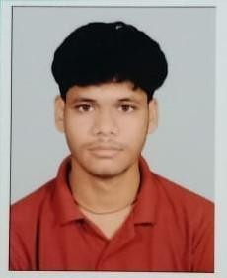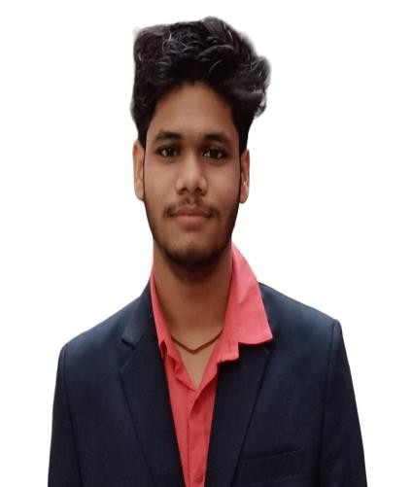

sign.jpg